Thank you for completing the work on our first Nurture principle with a focus on Safety. Most classes have identified safe spaces accessible to all pupils. Another area that children focussed on were improving the feeling of safety in the bathrooms, pupils helped Debbie, our Janitor, to oil the doors to stop the creaking sound and they have chosen to add artwork and plants into the bathrooms so they appear less clinical.

Principle 3: Nurture is important for the development of self-esteem.
“If a young person is granted space, support and time to grow, make and learn from their mistakes and develop, and the positive aspects of their journey are reinforced by adults, the strongest foundation for life can be built” (Nurture.org.uk)
What do we do already?
Restorative conversations, praise, Cool in School, buddies, baking, positive relationships with children and families, greeting every child, meaningful conversations and feedback, genuine praise, positive daily interactions, individual goals and strategies, Zones of Regulation, Head Teacher Awards, positive phone-calls or notes home……loads more!
During our last Nurture meeting, the reps chose this as the next principle they would like to focus on. Their ideas included celebrating personal achievements with a whole school display, reading stories to remind them of being kind and having manners, perseverance etc, Random acts of kindness, learning pit revision etc.
- From this week children will be told about our Achievement Tree/rainbow. Pupils will bring in handprints with a personal achievement on it. These will be collected in class and shared in classes once a month. They will then be added to the display by our Nurture Reps. These can be small achievements that are a big deal to individuals and not necessarily the same as Community News (big achievements collected as houses and shared at assembly).
TAKE HOME TASK
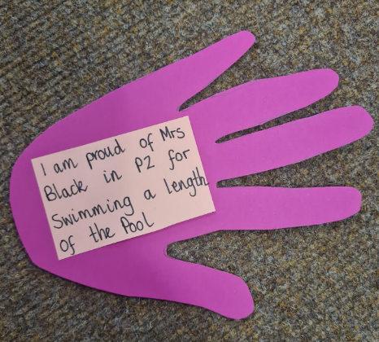
We are collecting your handprints! Draw around your child’s handprint on paper or card of your choice and write their name and class on it as well as their achievement – something that you are proud of out with school achievements e.g. learning a new skill such as tying laces, cooking a meal etc or sleeping in their own room,
having their first sleepover, trying new foods etc.. Bring these into class for our display. WE WOULD LIKE EVERY CHILD TO HAVE AT LEAST ONE HANDPRINT FOR THE DISPLAY BEFORE 26TH OF MAY
If you are unable to complete this at home, please email the achievement to the school and we will record this for you. The idea is, however, to share the proud feelings at home and then at school.

