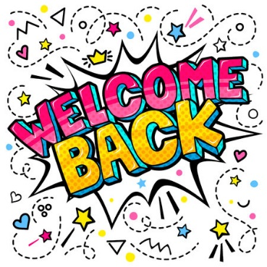

18.8.22

Primary 2 Newsletter

**Reading**

I have began to revise books read last term and will be sending out reading books next week.

**PARENT COUNCIL:**

We encourage as many parents as possible to attent Parent Council meetings. The AGM is very soon and can now be face to face again.

**P.E/Shoes**

We are now allowed to go back to changing for P.E. We will be changing in the classroom to allow adults to support children with laces/buttons etc. Pupils keep PE kit in school in a little bag. We are also going back to having indoor and outdoor shoes, pupils keep indoor shoes (usually trainers) in school and change into these when we are inside.

P.E. will be on Wednesday and Thursday (at the moment)

**Other info:**

Please return milk letters, DATA letters and Flu vaccine letters ASAP. Note that Milk is paid via ParentPay only this year.

Mrs Black is still our Learning Assistant and we met Mrs Coombs, the new school Principal Teacher and look forward to working with her.

**Chromebooks**

We will soon be allocating Chromebooks for use in class initially. Children will need time to get used to logging into these and looking after them before they go home. We will use Google Classroom for home learning/sharing info etc but for now, I will use the website to share any information.

Happy new school year ☺

I am excited to continue teaching the same class this year and have lots of fun lessons planned. We already voted on the first topic last term and have began to think about what questions we have about it.