Story of the Week
Title: “Blown Away” by Rob Biddulph
Online link: https://www.youtube.com/watch?v=l5cXmbbXcQQ

How the Book Can Support Children’s Learning
Health and Wellbeing:
- Sharing and enjoying a book together.
- Building relationships and having fun with your child.
- Talking about Friendship and helping each other out.
- Talking about feelings.

Literacy:
- Encouraging your child to listen to a story from beginning to end.
- Talking about the animals in the story and what happens to them.
- Talking about a favourite part of a story.
- Looking at the illustrations and listening to and talking about rhyming words.
- Predicting what might happen next in the story.
- Retelling a story in own words with or without puppets/props.

Numeracy:

- Counting items up to 10.
- Using number names up to 10.
- Using mathematical language – How many? How many altogether? One is lost …how many now?
- Using mathematical language…..bigger/ smaller
- Talking about and using 2D shapes…..triangle square circle kite

Possible Home Learning Experiences Linked to the Story
Things to talk about:
- The different animals, what they look like and where they come from.
- How many of each animal is holding on to the kite and how many altogether. Count the clouds and talk about the numbers together…. Which one is 3 ….Can we count 3 …Which one is 6 ….. Can we clap to 6 ….Can you find me 6 stones….Which is the biggest number?
- What do you see and how does it feel on a windy day?
- How do the animals feel when they are flying through the air?
- Would you like to fly through the air on a kite?
- How do they feel when they land on the island?
- Which would you most like to visit ….a hot place or a cold place. Why?
- How do the animals solve their problem?
- Talk about the ending …..Do you like how the story ends?
- If you could go on an adventure where would you like to fly to?

Things to do:
- Retell the story together using sound effects…..Find things around the house to make different sounds
- Draw a picture of your favourite part of the story
- Make pictures of hot places and cold places.
- Gather a collection of different animals (plastic figures or soft toys or different pictures ) and ask your child to sort these in different ways . Talk about how they have sorted them and different ways of doing this.
- Encourage your child to make a boat from recycled materials to take the animals home .Talk about the materials they have chosen and experiment with different ways to join materials together ( glue, sticky tape, hole punch and string, glue stick) Can it float? Test it in a basin of water

- Make kites from different shapes of paper and string. Decorate them in different ways and test them outside.

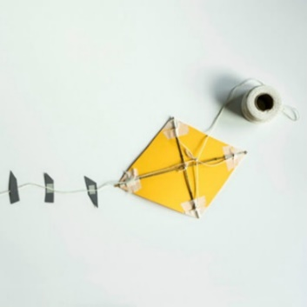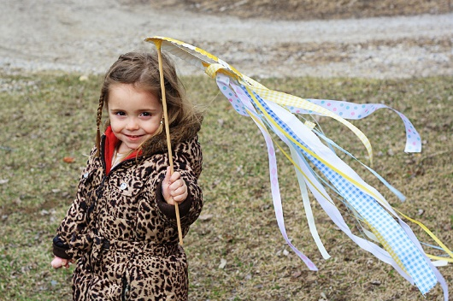

- Play guessing games ….I have flippers and a black and white body. I can’t fly ….Who am I ?
- Make up some games where you have to race against each other to blow the feather, piece of paper or ping pong ball across a table The winner is the one who gets to the other side first.
- Make an arctic world with playdough in a tray or basin. You can add glitter if you have any. Add some arctic animals and allow your child to use their imagination as they play and make up their own stories.

- Make kite sandwiches with different healthy fillings. Talk about what makes a healthy sandwich and prepare them together. Talk about the shapes of the sandwiches as you cut them into triangles and make kites.
- Find out about animals that live in cold countries and those which live in hot countries
- Experiment with hot and cold. Find some things around the house that feel warm to touch and some that feel cold.
- Make ice cubes and talk about how they feel. Think of words to describe them. Experiment with different ways to melt them using warm water / leaving them in the sun/putting salt on them / chipping at them with toy tools
- Talk about what happens to the ice when it melts. Put out some ice and some utensils for your child to play with.

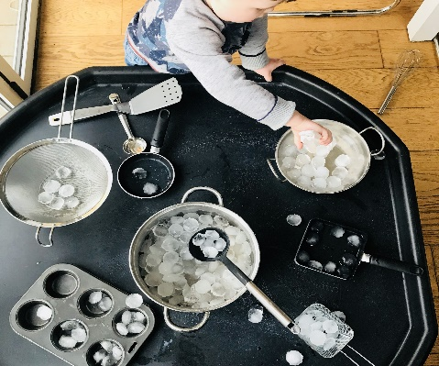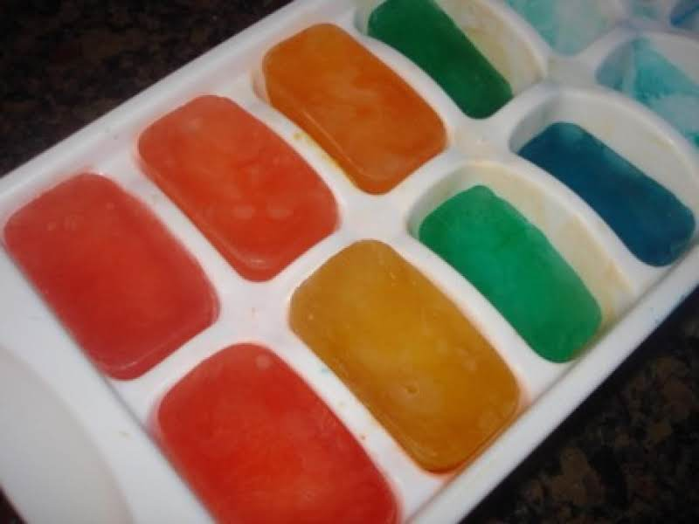

- Add food colouring mixed with water to ice cube trays . Leave the cubes to set overnight and have fun painting with them next day.

- Put some fruit in to ice cube trays before adding water and putting them in the freezer.
https://www.youtube.com/watch?v=KQIuAamRt6Q

- Make ice lollies
- Experiment with freezing different things in ice cubes…..leaves, daisies, flower petals, animals….. Have fun melting them to get to what’s hidden inside.

- Listen to more stories about arctic animals
https://www.bbc.co.uk/cbeebies/radio/story-time-penguin

