Story of the Week
“The Smartest Giant in Town” by Julia Donaldson
Online link:
https://www.youtube.com/watch?v=cfiPrA8E3qE
How the Book Can Support Children’s Learning
Health and Wellbeing:

- Exploring the theme of friendship and what it means to be a good friend.
- Beginning to develop an understanding of the importance of friendship, caring and sharing when building positive relationships.
- Talking about how we care for animals and nature and why this is important.

Literacy:

- Enjoyment of stories.
- Listening to a story from beginning to end.
- Joining in with the story, repeating key phrases together… “Look me up and look me down, I am the smartest giant in town.”
- Talking about the people in the story and what happens to them.
- Talking about a favourite part of a story/ favourite character in the story.
- Predicting what might happen next.
- Talking about the ending… Is it a good ending? Why? Why not ?
- Retelling a story in your own words with or without puppets/props.
- Making up your own story through role play, drawing pictures or writing.
- Talking about the rhyming words in the story and finding some rhyming words of your own.

Numeracy:

- Positional language – over, under, through.
- Counting how many characters there are in the story.
- Simple problem solving… How could we make a house for a mouse?
- What could the giant’s belt be used for?
- Sorting items into things that float/ don’t float.
- Comparing sizes.
- Using mathematical language bigger smaller longer shorter when talking about the giant and other characters in the story.

Possible Home Learning Experiences Linked to the Story
Things to talk about:

- Look at the front cover of the book and talk about what the story might be about.
- Think about what giants look like and find some words to describe them. Talk about what makes a giant different to you and your family.
- Talk about size… who is the biggest/smallest person in your family.
- Which are the tallest /shortest animals in the story.

Think about how George is feeling at the start of the story and what is making him feel like that.

- Have you ever felt sad like George? What made you feel like that and what helped you to feel better?
- How do you think the animals felt before they met George?
- How do you think the animals felt after they met George?

George was very kind to the animals.

- Talk about what it means to be kind. Talk about a time you have been kind. Who were you kind to? What did you do and how did it make them feel? How did George feel when the animals were kind to him?
- Talk about friendship and what makes a special friend.
- What sorts of things do you like to do with your friend? What are you looking forward to doing with your friend when you see them again?
- What did the animals do to say thank you to George?
- If you could give George some new clothes, what would you give him?

Things to do:

- George helps lots of different animals throughout the story. Think of a way that you could help somebody today.
- George helps the goat make a sail for a boat. Can you make your own boat using twigs, pieces of wood, corks, leaves? Does it float? Fill a basin with water and try it .Can it carry anything without sinking?
- What could you use to make a sail for your boat?

- Investigate which things float and which things sink- Gather some objects together e.g. pencil, stone, leaf, piece of Lego, sponge, paper Observe what happens when you put them in a basin of water. Have fun playing with the water looking for new things to experiment with. Can you make something that sinks float? Can you make something that floats sink? How?

- Sort into groups: “Things that float” and “Things that sink”. Make labels to put beside each group.
- Set up a Giant’s Clothes Shop. Make a sign for the shop, make price tags for the things you will sell. Make some pretend money or find things to use instead of coins e.g. stones, paper. Play pretend shops, taking turns to be the shopkeeper and then the giant, buying some new clothes to wear!

- Make and decorate crowns using paper, cardboard, paints, crayons. Experiment with sticking on shapes and odd bits of leftover recycling. Can you make it fit on your head? Make up a story about who you are and why you are wearing a crown.
- If you could choose some new clothes, what would you choose? Find some clothes to dress up in and make up stories.
- Make footprints in sand, mud, paint. Who has the biggest footprint? Who has the smallest? Set a trail of footprints to follow. As you follow them, use mathematical language:

E.g. Take 3 steps forwards… Stop…Turn right… Take 4 steps forwards… Go under the chair… Take 2 steps over the cushion… Look for some treasure that has been hidden.

- Can you make a house for a little animal… what will you use? Can you find things around the house to help you make it?
- Have fun designing some new pants for George. Experiment with different ways to make patterns.

- Make your own Thank You card for someone you love.
- Have fun taking giant steps……. Count how many giant steps it takes to walk to the kitchen door, the end of the garden. Count how many of your footsteps it takes to do the same?
- Read or listen to some other stories about giants:
  - Jack and the Beanstalk
https://www.youtube.com/watch?v=zurz-pL-uzw
  - Are giants always kind in stories? Which giant do you like best?

- Draw or paint a picture of your favourite giant.
- Help sort out the washing, put the socks in pairs, sort the clothes into groups for each person in your family.
- Talk about who has the biggest socks, pants, shirt and the smallest.
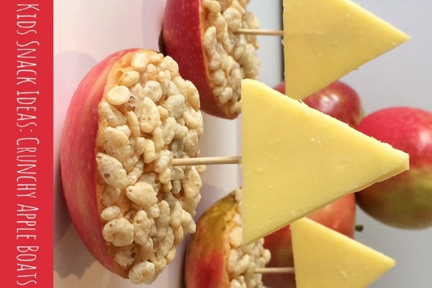
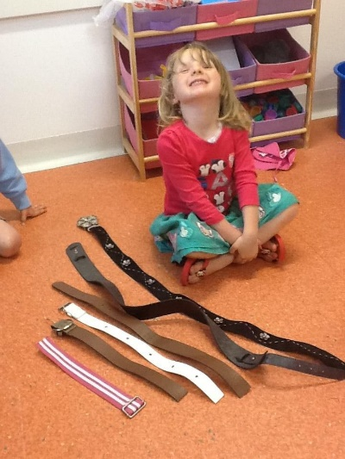
- Make a collection of belts you can find in the house…..Can you put them in order of size?

- Make some simple snacks with a boat theme….see above
- Make up a tune to go with George’s song and sing it together. Make some instruments from recycled materials to play along with:
https://www.activityvillage.co.uk/homemade-instruments-shaker

