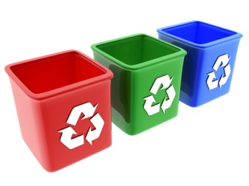
Goal To reduce the amount of waste in our school by recycling more.
Steps:
Think of ways to reduce the amount of waste we produce.
Get everyone to think about ways to reuse materials.
Recycle everything that we can.
Action | Who’s responsible? | Time target
Place small compost bins in the staffroom and both atriums. | Eco Committee | October 2011
Place plastic bottle recycling bins in each classroom. | Eco Committee | October 2011
Monitor use of these bins and empty regularly. | Eco Committee | Ongoing
Have regular assemblies to raise awareness of waste and recycling. | Eco committee  Whole school | Ongoing
Put information on the school website, Eco Notice board and in local library and church. | Eco Committee  Mrs Hunter/Miss Malcolm | Ongoing
Make signs to remind everyone what goes into each bin. | Eco Committee | December 2011
Make sure every class has a scrap paper tray. | All staff | May 2012
Monitor paper waste bins and make sure both sides are used before recycling. | Eco Committee  All pupils and staff | Ongoing
Get everyone to think of creative ways to reuse recyclable materials. | Eco Committee  All pupils and staff | May 2012
Monitor outside compost bins and begin using compost on the raised beds. | Eco Committee  Mrs Hunter/Miss Malcolm | June 2013

